Beaver Disturbance Assessment and Mapping Eightmile River Report 23-24
Evan Zocco, Chandi Witharana, Isaac M. Ortega
Introduction
Beavers have a complex history in Connecticut. By the late 1800s, the entire local beaver population had been eradicated due to the fur trade. Beaver pelts were highly sought after for the construction of top hats which demanded more pelts than the population could sustain. Additionally, the draining of wetlands significantly impacted the species. In the late nineteenth century, the Department of Environmental Protection successfully reintroduced beavers to the area. As of 2015, the beaver population was estimated to be between 6,000 and 10,000 individuals. This estimate has not been publicly updated since then and is subject to a significant degree of uncertainty.
The species thrives in Connecticut due to its instinct to construct dams in forested waterways. The state provides the necessary resources for the beavers to flourish. Typically, beavers are timid around humans and prefer secluded areas. However, continuous infrastructure development has fragmented core forests, removing suitable habitats. As a result, the population has adapted by settling closer to human infrastructure. This proximity has led to an increase in incidents involving private property and roadways. Affected members of the public have called for solutions to their flooded lands, while others advocate for allowing the beavers to remain undisturbed. This debate has garnered public interest over the past decades and requires careful consideration.
Methodology
A 29-year span of imagery from Connecticut was used to develop a model for creating beaver site inference maps of the Eightmile River watershed. The specific years analyzed within this span varied depending on funding availability, covering the period from 1990 to 2019. These were the layers available at the start of the study. All imagery utilized in this project was sourced through open-source platforms provided by the state of Connecticut. Sources included the Connecticut Environmental Conditions Online (CT ECO), the Connecticut Geodata Portal, and the University of Connecticut Center for Land Use Education and Research (CLEAR). These sources offer statewide aerial data at multiple resolutions for user analysis, ranging from 7.6 cm to 1 m. Orthomosaics of the state were resampled to a uniform resolution of 1 m^2, the lowest resolution available among the years used. This resampling was performed using the resample tool within the spatial analysis toolset of ESRI’s ArcGIS Pro. The resampled imagery was then tiled into 640 m^2 tiles from the original orthomosaics, created with no overlap to cover the entire state. Images were scrutinized for beaver sites across the years of imagery, with 600 total sites selected, distributed evenly over 12 years. Some sites exceeded the 640m^2 tile size, necessitating the selection of multiple overlapping tiles, each overlapping by at least 50 meters. These tiles were annotated using the "Create Feature" tool in ArcGIS Pro. The annotated images contributed to creating a training dataset. The dataset, comprising 8,500 images, was divided into training, validation, and testing subsets at proportions of 70%, 20%, and 10% respectively. Image augmentation was applied to the training dataset to enrich it further, with random augmentations performed on three copies of each image and annotation. The training employed the "You Only Look Once Version 8" (YOLOv8) model. Model performance was monitored using the test dataset, which had never been inputted into the model before. All the state’s chipsets for all twelve years were processed by the model, which delineated beaver sites as polygons. Inferences for the watershed were derived at a 75% confidence level, indicating the model’s certainty that a beaver site was present within the image.
Future Use
The georeferenced polygon inference facilitates the calculation of area and perimeter using basic tools available in ArcGIS Pro or QGIS. These metrics are crucial for habitat, resource, and wildlife management. Understanding the total habitat area of a keystone species like the beaver is essential for effective monitoring. Monitoring changes in beaver habitats is particularly important due to their significant ecological impact. Beaver damming can lead to severe flooding, which can both negatively and positively affect the environment. Forest managers often deal with plots of land that are heavily impacted by beaver-induced flooding. The dams constructed by beavers not only destroy surrounding vegetation through flooding but also lead to the felling of trees, which beavers use both as construction material and as a food source. The species profoundly affects hydrography by altering water height, flow velocity, and sediment retention. Such alterations to rivers and streams can lead to permanent changes in the surrounding ecosystems.
Recommendations
I recommend that this survey be conducted annually, coinciding with each aerial imagery flight. This approach would ensure that updates on beaver site areas are obtained as changes occur frequently. Analyzing these changes over time would offer a detailed narrative of the landscape and the interactions between humans and beavers. Additionally, if time permits, physically observing these sites as a form of ground truthing could be beneficial for assessing the model's accuracy.

Results
Total Area of Beaver Sites in Eightmile River Watershed
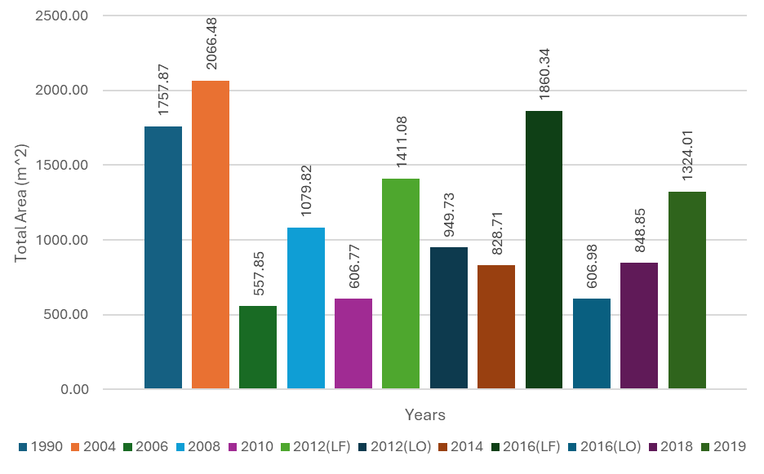
Total area of beaver site split by year for the total range of years utilized.
Total Count of Beaver Sites in Eightmile River Watershed
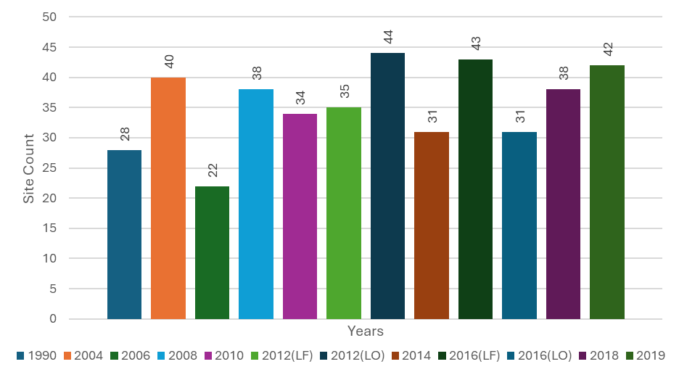
Total count of beaver site split by year for the total range of years utilized.

The total area of beaver sites within the Eightmile River watershed experienced significant fluctuations over a 29-year period. The years 1990 and 2004 showed an inconsistent increase compared to the data from 2006 and 2008. This inconsistency is likely due to the limitations of the model when analyzing greyscale imagery. Panchromatic or greyscale imagery, which comprises the smallest type of imagery used, presents challenges due to the extensive dataset collected from single-band imagery and the number of beaver sites identified in these years. Furthermore, imagery data collected during leaf-off periods reveal a significantly larger area compared to leaf-on periods. This discrepancy occurs because surface-level floating vegetation obscures the view, leading the model to mistakenly interpret the surrounding forest or woodland areas as being closer than they are.
Leaf Off Years 1990 to 2019
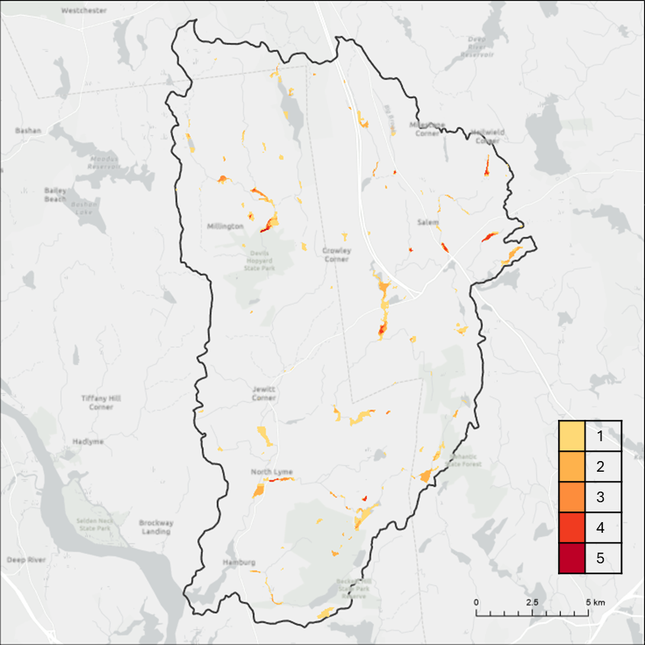
This map includes 1990, 2004, 2012, 2016, and 2019. All of these aerial flights were flown during the leaf off phenotypic phase preventing occlusion by deciduous leaves and surface vegetation.
Leaf Off Years 2012 to 2019
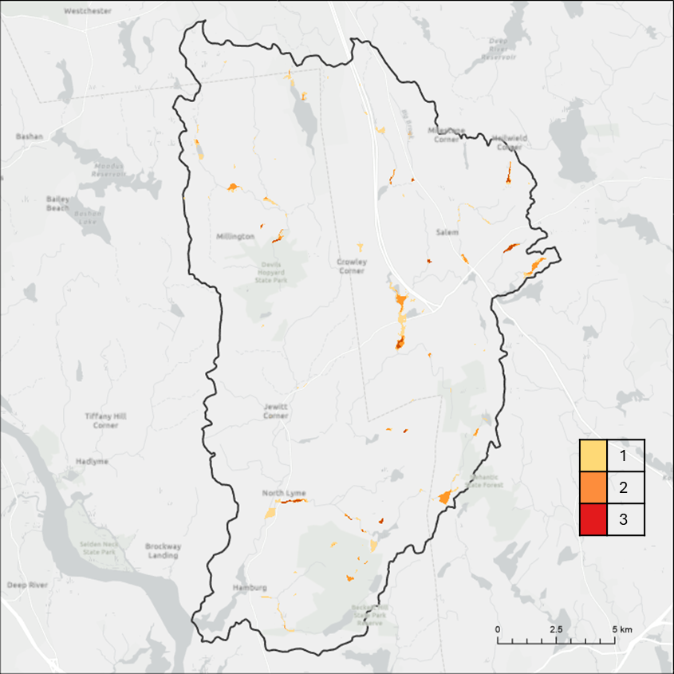
This map includes 2012, 2016, and 2019. All these aerial flights were flown during the leaf off phenotypic phase preventing occlusion by deciduous leaves and surface vegetation. This map removes greyscale imagery layers 1990 and 2004 to remove confusion in the model.
Leaf On Years 2006 to 2018
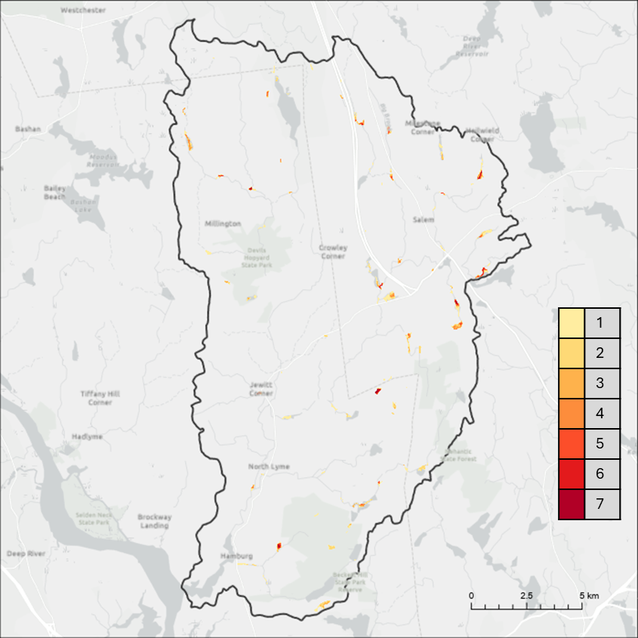
This map includes 2006, 2008, 2010, 2012, 2014, 2016, and 2010. All these aerial flights were flown during the leaf on phenotypic phase including deciduous leaves and surface vegetation in the imagery.
All Years 1990 to 2019
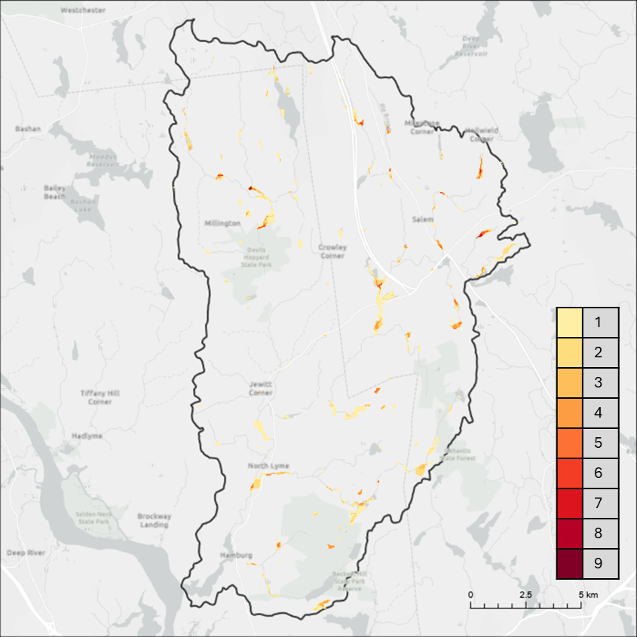
This map includes 1990, 2004, 2006, 2008, 2010, 2012 (Leaf on and off), 2014, 2016 (Leaf on and off), 2018, and 2019. These aerial flights were flown during the leaf off and on phenotypic phases and includes greyscale imagery layers 1990 and 2004.

The “Leaf Off Years 1990 to 2019” map contains 5 years of imagery and shows the total amount of area modified by beaver activity over the 29-year period of collected leaf off imagery. Leaf off imagery is collected within the phenotypic period where deciduous trees have shed their leaves. This imagery is free of occlusion from deciduous tree leavers and from surface level vegetation. Surface level vegetation confusion is not present in this imagery either. This map does contain two years of panchromatic imagery, which could cause model confusion. The “Leaf Off Years 2012 to 2019” map contains 3 years of imagery and shows the total amount of area modified by beaver activity over the 8-year period of collected leaf off imagery. This map contains the same advantages as the last and doesn’t include panchromatic imagery. The period for this map is much shorter than the previous but more accurate without the confusion from greyscale imagery. The “Leaf On Years 2006 to 2018” imagery map contains 7 years of imagery and shows the total amount of area modified by beaver activity over the 13-year period of collected leaf on imagery. This map contains summer imagery with occlusion. It is less accurate than the leaf off imagery maps but still contains important temporal fluctuations. The “All Years 1990 to 2019” map contains 12 years of imagery and shows the total amount of area modified by beaver activity over the entire 29-year period of collected leaf off and leaf on imagery.
Each of these maps are further analyzed in the figure below. The legend depicts years of modified area. This is just one example of the types of maps that can be created with this dataset.
Leaf Off Years 1990 to 2019 Example Site
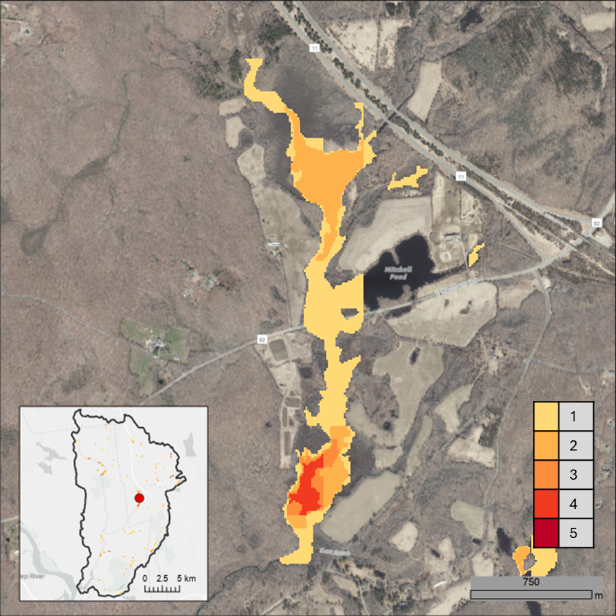
An example site within the watershed. Leaf off sites including years 1990, 2004, 2012, 2016, and 2019 and calculated to show years are land modification.
Leaf Off Years 2012 to 2019 Example Site
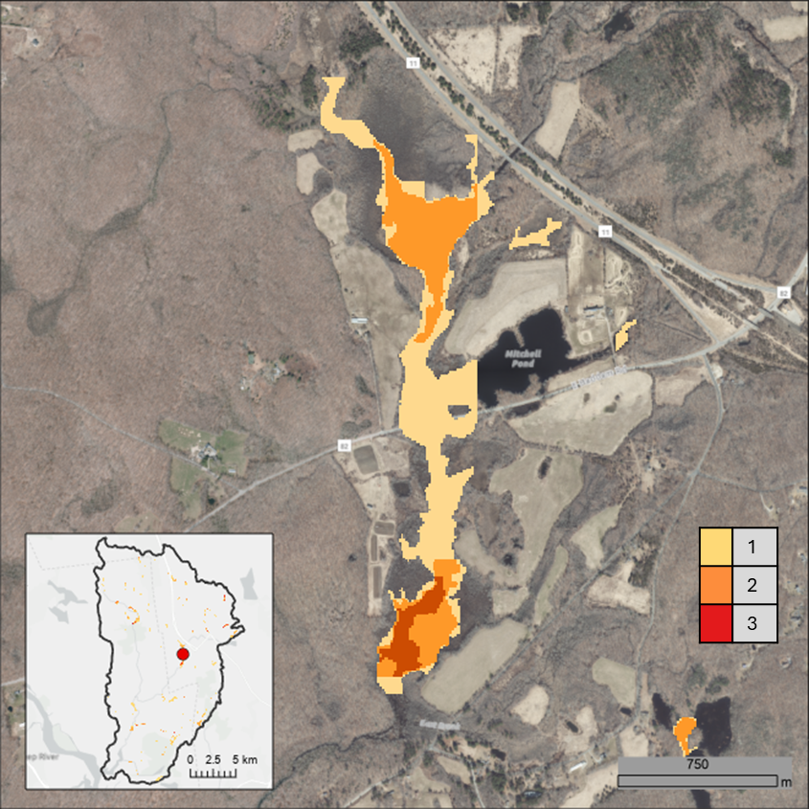
An example site within the watershed. Leaf off sites including years 2012, 2016, and 2019 and calculated to show years are land modification. 1990 and 2004 leaf off years are not included to prevent greyscale image confusion.
Leaf On Years 2006 to 2018 Example Site
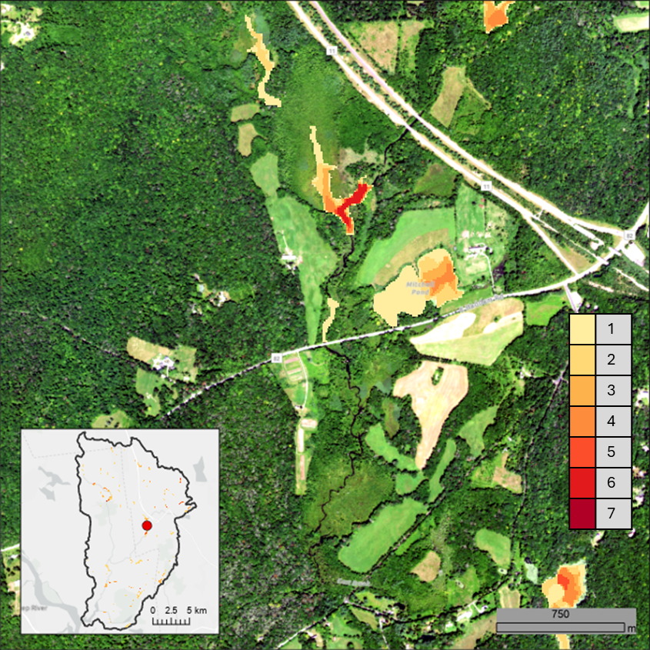
An example site within the watershed. Leaf on sites including years 2006, 2008, 2010, 2012, 2014, 2016, and 2018 and calculated to show years are land modification.
All Years 1990 to 2019 Example Site
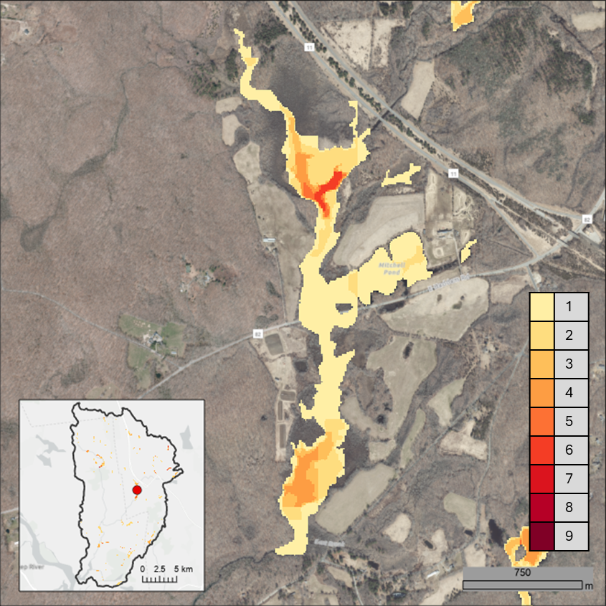
An example site within the watershed. Leaf on and leaf off sites including years 1990, 2004, 2006, 2008, 2010, 2012 (leaf on and off), 2014, 2016 (leaf on and off), 2018, and 2019 and calculated to show years are land modification.

Yearly Maps
The maps below are the yearly inferences of the beaver sites for the Eightmile River watershed. Similar issues to what was mentioned before are present when comparing the leaf off and leaf on imagery. Occlusion by leave and surface vegetation create confusion which are represented by false positives (detected background as beaver sites) and false negatives (failing to detect beaver site).
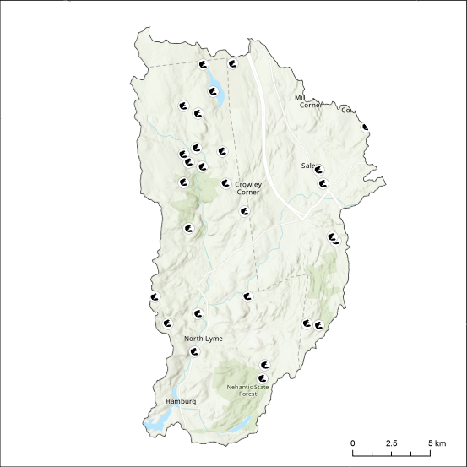
1990 Leaf off beaver sites within the Eightmile River watershed
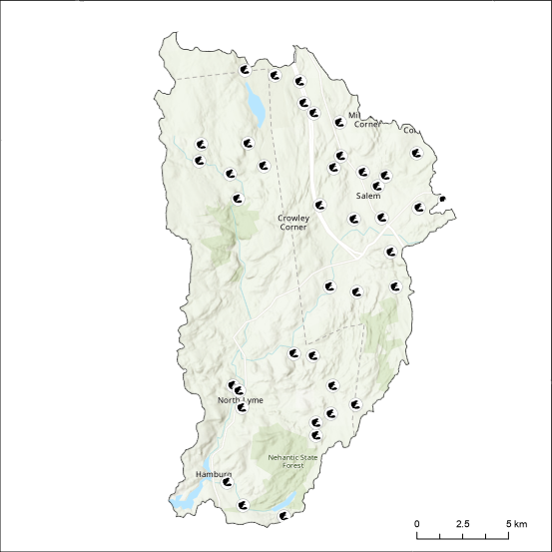
2004 Leaf off beaver sites within the Eightmile River watershed
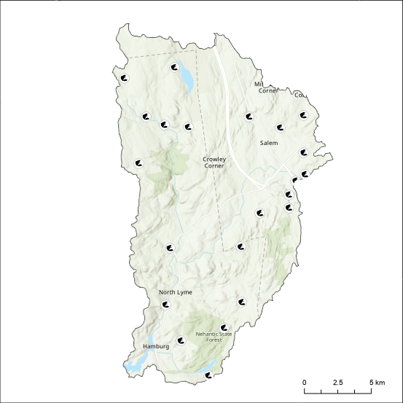
2006 Leaf on beaver sites within the Eightmile River watershed
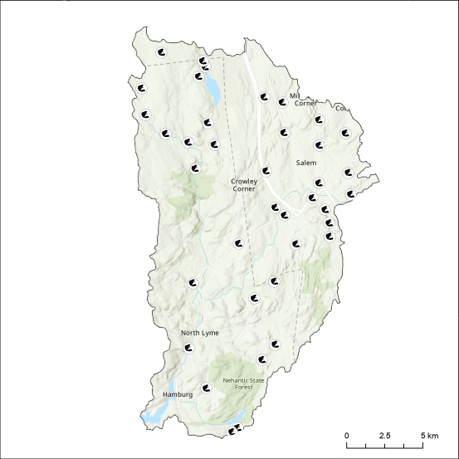
2008 Leaf on beaver sites within the Eightmile River watershed
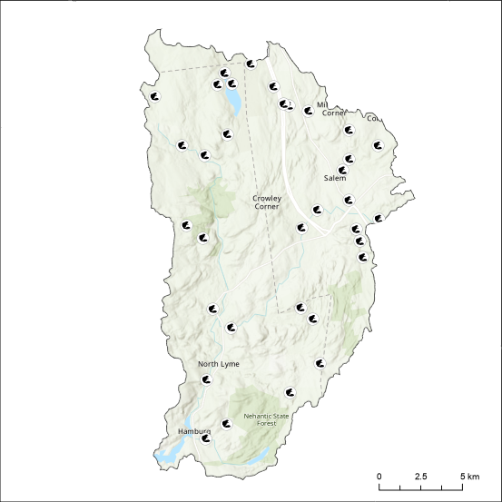
2010 Leaf on beaver sites within the Eightmile River watershed
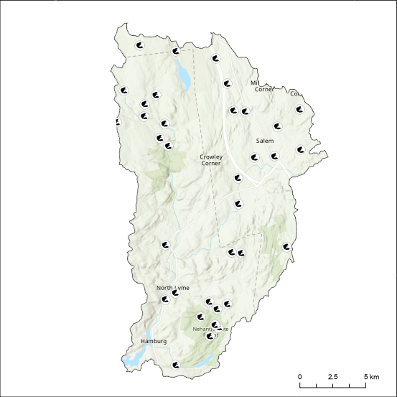
2012 Leaf off beaver sites within the Eightmile River watershed
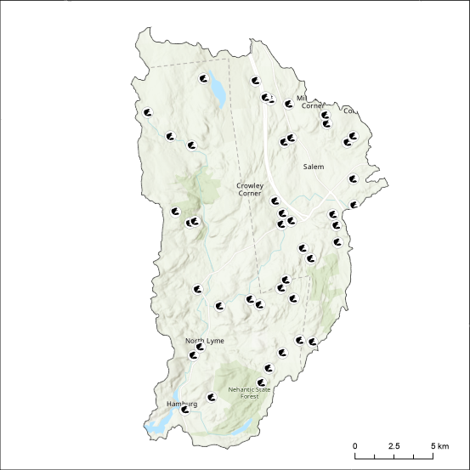
2012 Leaf on beaver sites within the Eightmile River watershed
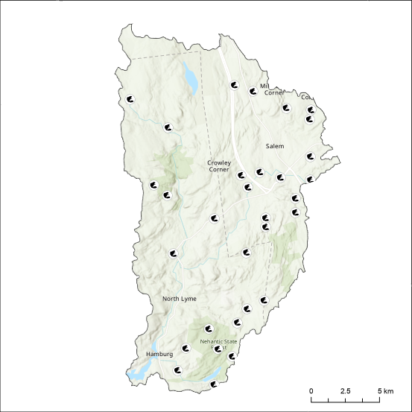
2014 Leaf on beaver sites within the Eightmile River watershed
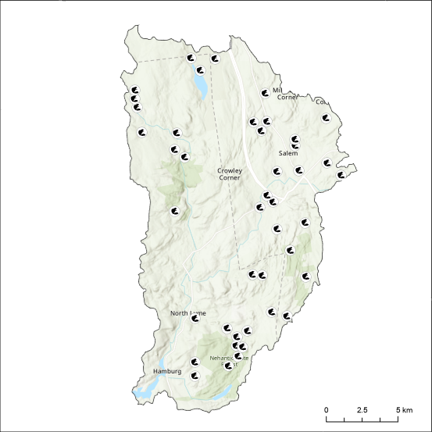
2016 Leaf off beaver sites within the Eightmile River watershed
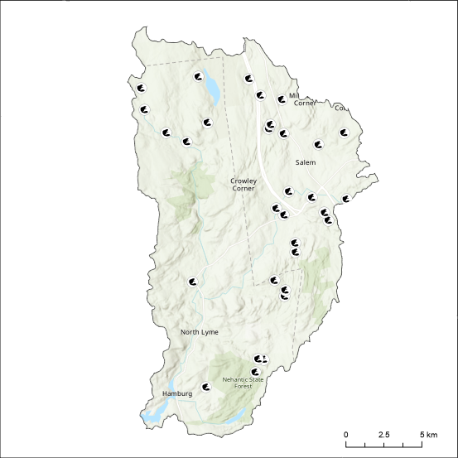
2016 Leaf on beaver sites within the Eightmile River watershed
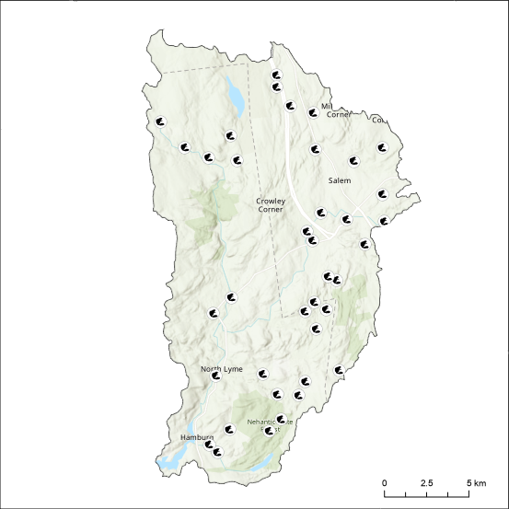
2018 Leaf on beaver sites within the Eightmile River watershed
2019 Leaf off beaver sites within the Eightmile River watershed

